STB AUTOMATION TESTING SOFTWARE

**Literature Survey:**

I went to Chennai and gathered information about automation testing and STB Automation Testing from software testing engineers of TCS and HCL.

1. **Why we choose Automation Testing domain?**

Because it is a trending domain

1. **Why STB Automation Testing?**

Because there are only few software in the market and they are costly. And corporates are looking for open source software.

1. **System Study:**

*Could we able to develop services for all the test*

Resulting in listing down the API

*Whether it is possible to do in lab setup*

Yes it is possible

*Existing system pros and cons analysis*

1. TCS’s private testing :: Private Software
2. Stromtest :: Costly
3. STB-Tester One :: Performance testing [checks the time taken for an action to complete]
4. Wig bee :: Mobile Automation Testing
5. Selenium :: Browser Automation Testing

*Whether it is worth doing the project*

As far as I check the project idea is the most trending idea in the software testing sector

*What are the technologies we are going to use?*

Created Services in JAVA

*How the architecture of this software and flow of the process*

Local machine

Video player

Capture Image

Select region

Test

Load script

Run script

LOG DATA

*How to connect with Set Top Box*

The hardware set up is not possible in the lab environment. Since we proposed the POC for the functionalities as the project the hardware setup is not required. Instead of that we can use sample video.

***Reference:***

*Ms Grace Deepika*, *Project Leader, HCL*

[gracedeepikapaul@gmail.com](mailto:gracedeepikapaul@gmail.com)

*Ms.Priyanga, Sr.* *Software Testing Engineer, HCL*

+91 8807012813

*Mr David, Reporting Manager, HCL*

[PJ.davidrajesh@gmail.com](mailto:PJ.davidrajesh@gmail.com)

*Mr Nithin Christopher, Software Testing Engineer, HCL* [snithinchristopher@gmail.com](mailto:snithinchristopher@gmail.com)

They are working in Verizon Telecom project [Set Top Box development]. Based on their feedbacks and suggestions I proposed the idea to develop “STB Automation Testing Software” as my final year project.

**Work Did So Far**

Literature Survey till dec 20

After JAN : <http://ecampus.kgisliim.ac.in/moodle/mod/forum/discuss.php?d=7096>

**Module Split-up**

**FUNCTIONILITY MODULES:**

1. ***Image Comparison***
2. ***Color Comparison***
3. Audio Detection
4. Video Detection
5. **Text Extraction**

**UI MODULES:**

1. ***Video panel***
2. ***Image preview panel***
3. **Script run panel**
4. Output view panel
5. Integration

[Completed Modules are in Bold and Italics]

**Work of Functionality Modules:**

1. Image Comparison – The STB testing is complete Image based testing so all the test operation need a comparison of sample image and image captured during playback.
2. Color Comparison – To test the RGB values of the image. It’s like a child service of Image Comparison
3. Audio Detection. – To test whether the audio is working.
4. Video Detection. – To test whether the video is running
5. Text Extraction – To get to know in which page we are

**Lines of Code:**

HTML 67

CSS 45

JS 323

JAVA 72+207+279+59+30+12+52+25+188+50+45+90+126 = 1235

Total 1,670 [PRE-DEFINED AND LIBRARY FILES NOT INCLUDED]

**GITHUB** <https://github.com/snaveenandrew/STB-Automation-Testing>

**CURRENT STATUS:**

SERVICE : log data

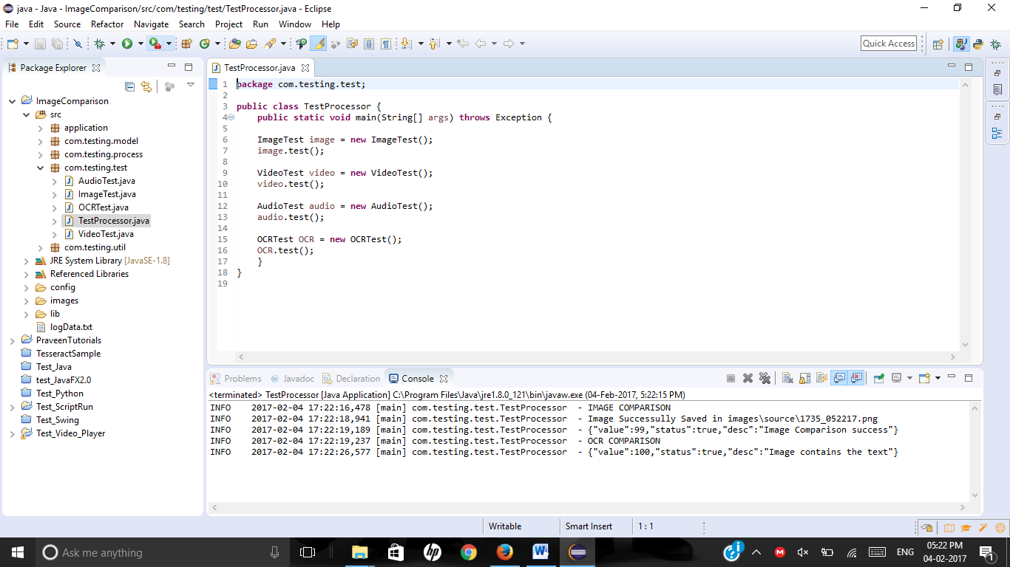

**User Interface:**

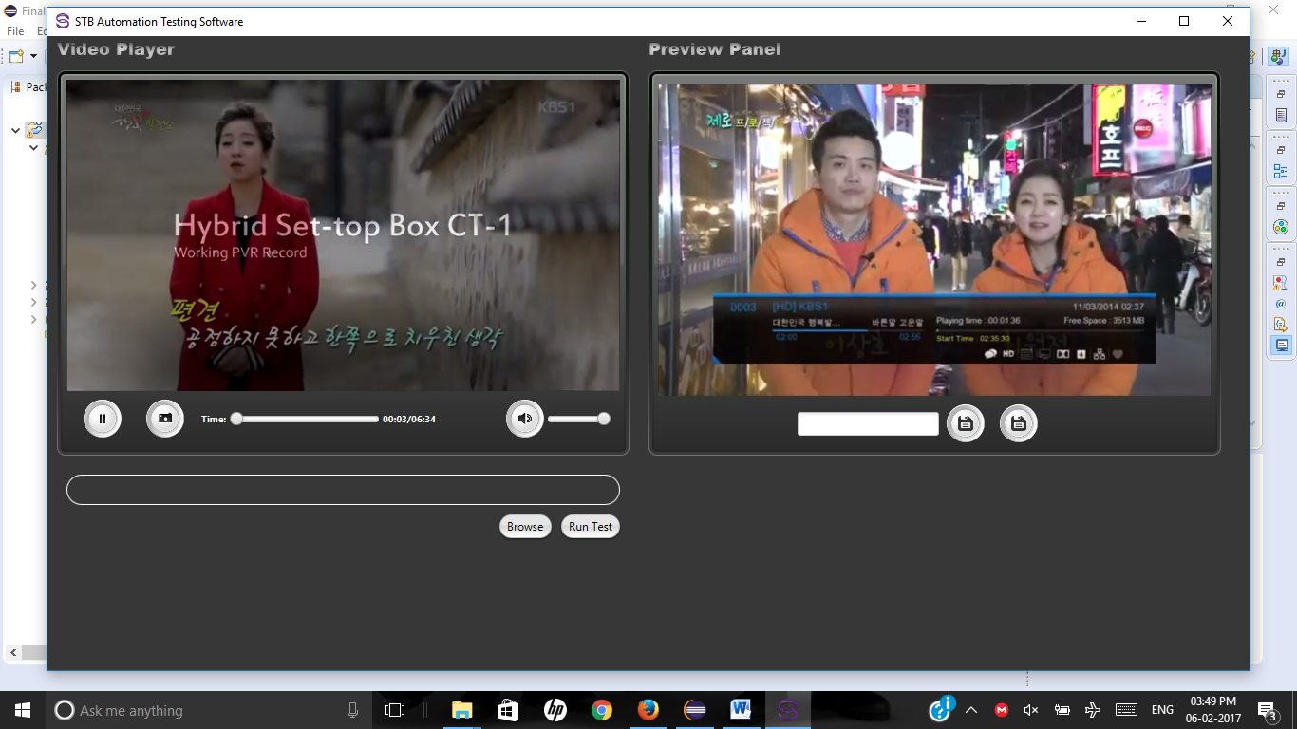

Main UI

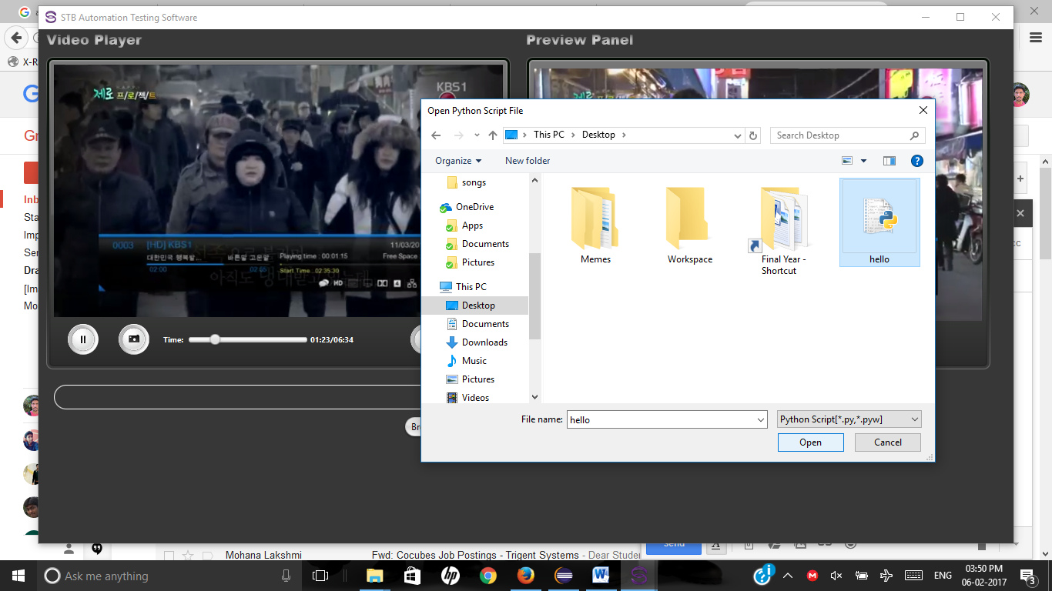

Open File Browser

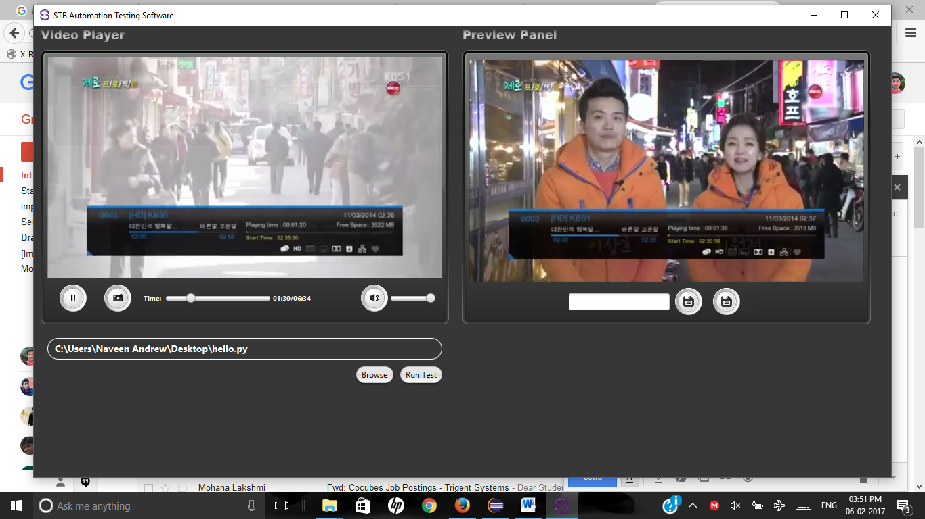

Run script

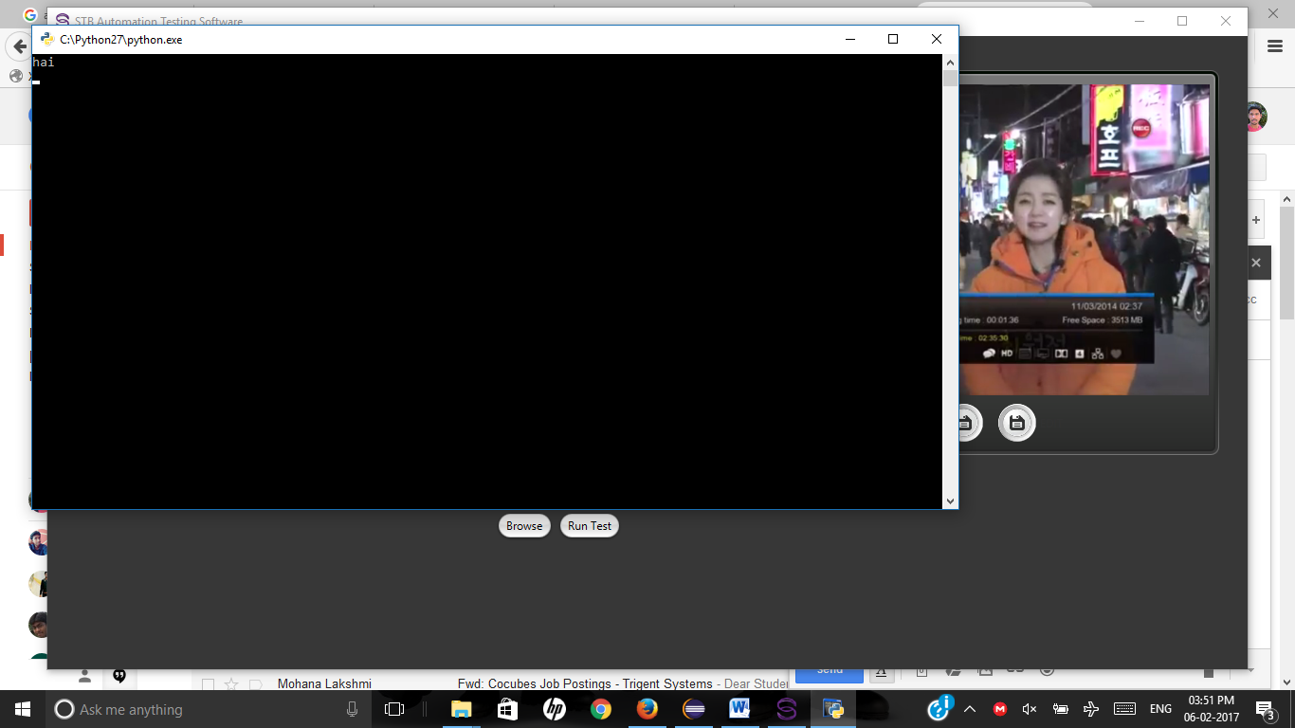

Script Running

Now, I am stuck with a problem and I had posted the question in Stack overflow and 2 days ago. If you can, please give your solution.

<http://stackoverflow.com/questions/41976356/group-rectangle-and-imageview-javafx>